Time Sensitive Document
Estoppel Conditions Apply Upon Default

Maneka Helleberg, Chairman WFA
Dolores Cahill, President WFA
Heiko Schöning, Vice President WFA
Mads Palsvig, Treasurer WFA (Collectively, “We”, “us” or “our”)
Henningsens Alle 52,
2900 Hellerup, Denmark
info@worldfreedomalliance.org

<Date of sending the letter>
<Name>, acting as
The Hon <Name> MP
<Title> and

<Legal Name of Country (Collectively “You” or “Your”)
Adress,
Country>

Final Notice, Notice of Default Judgment and Notice of Liability

Re: European Spring Appeal: Hope & Accountability

Dear <name>,

We notice you failed to reply to both of our previous notices, the first titled “Declaration and Notice of Liability” dated <date of sending first notice> and the second titled “Default Notice and Notice of Liability” dated <date of sending second notice>, where;

- We made a number of assertions that remain unrebutted and undisputed, and

- You were respectfully commanded by us to deliver to us certain evidence concerning the alleged SARS-CoV2 (alleged) pandemic.

Your failure to reply to both notices within the time stipulated is taken as your first default and your second default.

We afford you this third and final opportunity to correct your commercial default and your dishonour, and respectfully command you this third and final time to reply and answer the following eight paragraphs:
Take Notice:

- There is no evidence to support a ‘SARS-CoV2’ medical emergency. Treatments and cures for influensa like symptoms and illness should have been made available to all patients. To keep these treatments from sick people is causing unnecessary harm. When effective preventions and treatments are already available, there is no necessity for any lockdown measures to be implementerad around the world, such as wearing of masks, quarantining, mRNA gene therapy/vaccines etc.

- Is there evidence that SARS-CoV2 has been isolated and validated by independent groups world wide?

- Most, if not all, of the mRNA gene therapies/vaccines are in clinical trials. They are experimental. There is evidence that there has been significant adverse events and death around the world and we fear the long term adverse repercussions may cause significant harms, injuries and loss.
- Any coercion of people to take SARS-CoV2 mRNA gene therapies/vaccines, whether directly through government legislation, or indirectly through government, police, and army directions, such as COVID19 Passports or by forced injection or coerced injection, without full consent, free consent and informed consent, is unlawful, immoral and unethical. Any sanctions for not taking the injection/vaccination, along with any measures of coercion and implementation of forced or coerced injection/vaccinations, must cease immediately.

- I Infringement of our inalienable rights and freedoms by so-called ‘pandemic’ laws are unnecessary, unfounded, unconstitutional, undemocratic, unlawful, illegal, criminal, and may incur liabilities on the enforcer and promoters for harm, loss and/or injury caused and must cease immediately. Civil actions may proceed immediately for damages caused by forced and/or coerced injections/vaccinations. Infringement of our inalienable rights and freedom, such as the wearing of masks, social distancing, travel and work restrictions, injections/vaccinations, microchipping, quarantining, remaining indoors, are unlawful.

- Direct and indirect Censorship regarding SARS-CoV2 and related issues, whether under the guise of “fact checking”, untrue or misleading media reporting, omissions, fabrications, outright lies and propaganda from governments, media, medical professionals, medical/drug companies and any other conspirators are to cease immediately or accept full liability and culpability for negligence, harm and injury caused to men and women.

- If the acts are found to be unlawful and criminal, the crimes committed by individuals, corporations, governments, organisations, and men and women acting in whatever role or capacity regarding the above statements, are crimes against mankind. Failure to comply to this Declaration and Demand Notice to immediately cease with all unlawful acts, criminal acts, crimes and offences against men and women by <date 2 weeks from the date of this letter> may result in criminal prosecution of all perpetrators, and/or civil action, relying upon each country’s constitutions and criminal legislation as well as the Universal Declaration of Human Rights, including but not limited to, continuing the application of the SARS-CoV2 vaccination program. Those offenders committing unlawful acts and crimes against the common people will be brought to justice expeditiously.

- We command you to provide evidence of the following;

- SARS-CoV2 has been successfully isolated.

- SARS-CoV2 injections/vaccines has been thoroughly tested, to ensure safety to all recipients.

- SARS-CoV2 injections/vaccines protect from SARS-CoV2 infection.

- SARS-CoV2 injections/vaccinations are not causing more harm than good, and are not causing significant adverse events, are not causing severe adverse events and are not causing death to recipients of the injections/vaccines.

- SARS-CoV2 injections/vaccination has not caused or led to thousands of deaths of recipients of the injections/vaccine.

Should you fail, refuse or neglect to deliver to us the evidence sought within the above paragraph 8, nor rebut the seven paragraphs preceding it, within 14 days of the date of this notice (third and final demand notice), it will be taken as your third default and a default judgment against you by reason of your silence and acquiescence.

- In the absence and/or refusal of your reply and answers to the above paragraph 8 within the time stipulated, that your silence is validly taken as your assent, agreement and acknowledgement;

- Your contribution and participation, whether directly or indirectly, consciously or unconsciously, to the SARS-CoV2 program makes you complicit to having caused and causing harm, significant and serious adverse injuries/events and even deaths, loss and

- You are legally and lawfully liable and culpable for your own actions, as well as your actions in conjunction with others, regarding the SARS-CoV2 injection/vaccination and lockdown programs, and

- We believe you are at risk of being liable if you do not take appropriate action to attempt, to abate or prevent harm, injuries and/or loss to men, women, children, new and expectant mothers and their babies or the people of Sweden and

- All indemnities, warranties, legislation and protections afforded you in relation to damages and injuries caused the common people, recipient victims of the SARS-CoV2 vaccines, are waived and voided, and you acknowledge your personal liability, culpability, vulnerability and accountability for every injured party of a SARS-CoV2 Vaccination.

Naturally, should you express to us in writing in timely manner, and certainly prior to <date 2 weeks from the date of this letter>, that all SARS-CoV2 injections/vaccines are withdrawn and all SARS-CoV2 injection/vaccination programs are immediately terminated, that no future Sars-CoV2 or other such sinister vaccination programs will be entertained or created by any government of <Country> , we will immediately withdraw from, terminate and not pursue any litigation and prosecution of crimes you committed, against you.

We anticipate this Notice clarifies our disposition to your various injection/vaccination programs and agendas.

Take Notice you have been fairly and equitably fore-noticed and fore-warned.

Qui non obstat quod obstare potest facere videtur

Supported By:

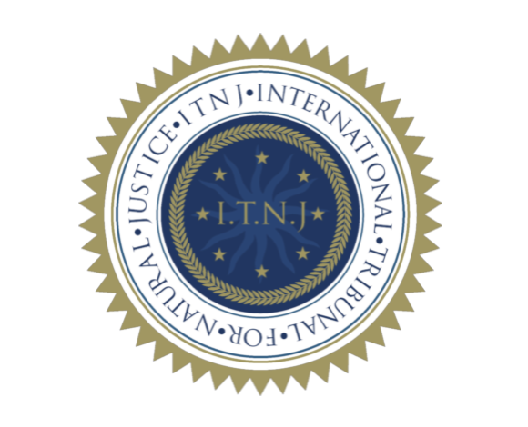

By Maneka Helleberg, Chairman WFA, Authorised Representative WFA,
Signature:
Maneka JC Helleberg

By Dolores Cahill, President World Freedom Alliance
Signature:
Dolores Cahill

Original signatures available on file

