**NOTICE OF LIABILITY**

PERSON RECEIVING NOL: PERSON SERVING NOL:

\_\_\_\_\_\_\_\_\_\_\_\_\_\_\_\_\_\_\_\_\_\_\_\_\_\_\_\_\_\_\_\_\_\_\_\_\_\_\_\_\_ \_\_\_\_\_\_\_\_\_\_\_\_\_\_\_\_\_\_\_\_\_\_\_\_\_\_\_\_\_\_\_\_\_\_\_\_\_\_\_\_

FIRST NAME, LAST NAME FIRST NAME, LAST NAME

\_\_\_\_\_\_\_\_\_\_\_\_\_\_\_\_\_\_\_\_\_\_\_\_\_\_\_\_\_\_\_\_\_\_\_\_\_\_\_\_\_ \_\_\_\_\_\_\_\_\_\_\_\_\_\_\_\_\_\_\_\_\_\_\_\_\_\_\_\_\_\_\_\_\_\_\_\_\_\_\_\_

PLACE OF SERVICE SIGNATURE

\_\_\_\_\_\_\_\_\_\_\_\_\_\_\_\_\_\_\_\_\_\_\_\_\_\_\_\_\_\_\_\_\_\_\_\_\_\_\_\_\_

TIME AND DATE OF SERVICE

This Notice of Liability has been SERVED to you personally.

You may be held personally liable for harm and death caused by implementation of

the proposal identified as REGULATION OF THE EUROPEAN PARLIAMENT AND OF THE COUNCIL on a framework for the issuance, verification and acceptance of interoperable certificates on vaccination, testing and recovery to facilitate free movement during the COVID-19 pandemic (Digital Green Certificate),Brussels, 17.3.2021 COM(2021) 130 final 2021/0068 (COD), which is designed to coerce widespread acceptance of experimental vaccination. If you take further action supporting such implementation, and if you take no steps to mitigate your past actions supporting such implementation, you may be held personally liable for resulting harm and death.

Attached as appendices and as integral parts of this Notice of Liability are the documents: Urgent Open Letter from Doctors and Scientists to the European Medicines Agency regarding COVID-19 Vaccine Safety Concerns; Reply from the European Medicines Agency to Doctors for Covid Ethics; Doctors and Scientists Accuse Medical Regulator of Downplaying COVID-19 Vaccine Dangers; Rebuttal Letter to European Medicines Agency from Doctors for Covid Ethics; Doctors for Covid Ethics Signatories.

Furthermore, you may be held personally responsible for supporting CRIMES AGAINST HUMANITY, defined as acts that are purposely committed as part of a widespread or systematic policy, directed against civilians, committed in furtherance of state policy.

Please respond to this NOTICE OF LIABILITY within 14 days from the DATE OF SERVICE, in writing, to the following address:

[ADDRESS OF PERSON SERVING NOL, OR OF THE ORGANIZER]

APPENDIX I

Urgent Open Letter from Doctors and Scientists to the European Medicines Agency Regarding COVID-19 Vaccine Safety Concerns

Emer Cooke

Executive Director

European Medicines Agency

Amsterdam

The Netherlands

28 February 2021

Dear Sirs/Mesdames,

**FOR THE URGENT PERSONAL ATTENTION OF:**

**EMER COOKE**

**EXECUTIVE DIRECTOR OF THE EUROPEAN MEDICINES AGENCY**

**BY EMAIL ONLY**

As physicians and scientists, we are supportive in principle of the use of new medical interventions which are appropriately developed and deployed, having obtained informed consent from the patient. This stance encompasses vaccines in the same way as therapeutics.

We note that a wide range of side effects is being reported following vaccination of previously healthy younger individuals with the gene-based COVID-19 vaccines. Moreover, there have been numerous media reports from around the world of care homes being struck by COVID-19 within days of vaccination of residents. While we recognise that these occurrences might, every one of them, have been unfortunate coincidences, we are concerned that there has been and there continues to be inadequate scrutiny of the possible causes of illness or death under these circumstances, and especially so in the absence of post-mortems examinations.

In particular, we question whether cardinal issues regarding the safety of the vaccines were adequately addressed prior to their approval by the European Medicines Agency (EMA).

As a matter of great urgency, we herewith request that the EMA provide us with responses to the following issues:

1. Following intramuscular injection, it must be expected that the gene-based vaccines will reach the bloodstream and disseminate throughout the body [1]. We request evidence that this possibility was excluded in pre-clinical animal models with all three vaccines prior to their approval for use in humans by the EMA.

2. If such evidence is not available, it must be expected that the vaccines will remain entrapped in the circulation and be taken up by endothelial cells. There is reason to assume that this will happen particularly at sites of slow blood flow, i.e. in small vessels and capillaries [2]. We request evidence that this probability was excluded in pre-clinical animal models with all three vaccines prior to their approval for use in humans by the EMA.

3. If such evidence is not available, it must be expected that during expression of the vaccines’ nucleic acids, peptides derived from the spike protein will be presented via the MHC I - pathway at the luminal surface of the cells. Many healthy individuals have CD8-lymphocytes that recognize such peptides, which may be due to prior COVID infection, but also to cross-reactions with other types of Coronavirus [3; 4] [5]. We must assume that these lymphocytes will mount an attack on the respective cells. We request evidence that this probability was excluded in pre-clinical animal models with all three vaccines prior to their approval for use in humans by the EMA.

4. If such evidence is not available, it must be expected that endothelial damage with subsequent triggering of blood coagulation via platelet activation will ensue at countless sites throughout the body. We request evidence that this probability was excluded in pre-clinical animal models with all three vaccines prior to their approval for use in humans by the EMA.

5. If such evidence is not available, it must be expected that this will lead to a drop in platelet counts, appearance of D-dimers in the blood, and to myriad ischaemic lesions throughout the body including in the brain, spinal cord and heart. Bleeding disorders might occur in the wake of this novel type of DIC-syndrome including, amongst other possibilities, profuse bleedings and haemorrhagic stroke. We request evidence that all these possibilities were excluded in pre-clinical animal models with all three vaccines prior to their approval for use in humans by the EMA.

6. The SARS-CoV-2 spike protein binds to the ACE2 receptor on platelets, which results in their activation [6]. Thrombocytopenia has been reported in severe cases of SARS-CoV-2 infection [7]. Thrombocytopenia has also been reported in vaccinated individuals [8]. We request evidence that the potential danger of platelet activation that would also lead to disseminated intravascular coagulation (DIC) was excluded with all three vaccines prior to their approval for use in humans by the EMA.

7. The sweeping across the globe of SARS-CoV-2 created a pandemic of illness associated with many deaths. However, by the time of consideration for approval of the vaccines, the health systems of most countries were no longer under imminent threat of being overwhelmed because a growing proportion of the world had already been infected and the worst of the pandemic had already abated. Consequently, we demand conclusive evidence that an actual emergency existed at the time of the EMA granting Conditional Marketing Authorisation to the manufacturers of all three vaccines, to justify their approval for use in humans by the EMA, purportedly because of such an emergency.

**Should all such evidence not be available, we demand that approval for use of the gene-based vaccines be withdrawn until all the above issues have been properly addressed by the exercise of due diligence by the EMA.**

There are serious concerns, including but not confined to those outlined above, that the approval of the COVID-19 vaccines by the EMA was premature and reckless, and that the administration of the vaccines constituted and still does constitute “human experimentation”, which was and still is in violation of the Nuremberg Code.

In view of the urgency of the situation, we request that you reply to this email within seven days and address all our concerns substantively. Should you choose not to comply with this reasonable request, we will make this letter public.

**This email is copied to:**

**Charles Michel, President of the Council of Europe**

**Ursula von der Leyen, President of the European Commission.**

* **References**

[1] **Hassett, K. J.; Benenato, K. E.; Jacquinet, E.; Lee, A.; Woods, A.; Yuzhakov, O.; Himansu, S.; Deterling, J.; Geilich, B. M.; Ketova, T.; Mihai, C.; Lynn, A.; McFadyen, I.; Moore, M. J.; Senn, J. J.; Stanton, M. G.; Almarsson, Ö.; Ciaramella, G. and Brito, L. A.** (**2019**). *Optimization of Lipid Nanoparticles for Intramuscular Administration of mRNA Vaccines*, Molecular therapy. Nucleic acids 15 : 1-11.

[2] **Chen, Y. Y.; Syed, A. M.; MacMillan, P.; Rocheleau, J. V. and Chan, W. C. W.** (**2020**). *Flow Rate Affects Nanoparticle Uptake into Endothelial Cells*, Advanced materials 32 : 1906274.

[3] **Grifoni, A.; Weiskopf, D.; Ramirez, S. I.; Mateus, J.; Dan, J. M.; Moderbacher, C. R.; Rawlings, S. A.; Sutherland, A.; Premkumar, L.; Jadi, R. S. and et al.** (**2020**). *Targets of T Cell Responses to SARS-CoV-2 Coronavirus in Humans with COVID-19 Disease and Unexposed Individuals*, Cell 181 : 1489-1501.e15.

[4] **Nelde, A.; Bilich, T.; Heitmann, J. S.; Maringer, Y.; Salih, H. R.; Roerden, M.; Lübke, M.; Bauer, J.; Rieth, J.; Wacker, M.; Peter, A.; Hörber, S.; Traenkle, B.; Kaiser, P. D.; Rothbauer, U.; Becker, M.; Junker, D.; Krause, G.; Strengert, M.; Schneiderhan-Marra, N.; Templin, M. F.; Joos, T. O.; Kowalewski, D. J.; Stos-Zweifel, V.; Fehr, M.; Rabsteyn, A.; Mirakaj, V.; Karbach, J.; Jäger, E.; Graf, M.; Gruber, L.-C.; Rachfalski, D.; Preuß, B.; Hagelstein, I.; Märklin, M.; Bakchoul, T.; Gouttefangeas, C.; Kohlbacher, O.; Klein, R.; Stevanović, S.; Rammensee, H.-G. and Walz, J. S.** (**2020**). *SARS-CoV-2-derived peptides define heterologous and COVID-19-induced T cell recognition*, Nature immunology.

[5] **Sekine, T.; Perez-Potti, A.; Rivera-Ballesteros, O.; Strålin, K.; Gorin, J.-B.; Olsson, A.; Llewellyn-Lacey, S.; Kamal, H.; Bogdanovic, G.; Muschiol, S. and et al.** (**2020**). *Robust T Cell Immunity in Convalescent Individuals with Asymptomatic or Mild COVID-19*, Cell 183 : 158-168.e14.

[6] **Zhang, S.; Liu, Y.; Wang, X.; Yang, L.; Li, H.; Wang, Y.; Liu, M.; Zhao, X.; Xie, Y.; Yang, Y.; Zhang, S.; Fan, Z.; Dong, J.; Yuan, Z.; Ding, Z.; Zhang, Y. and Hu, L.** (**2020**). *SARS-CoV-2 binds platelet ACE2 to enhance thrombosis in COVID-19*, Journal of hematology & oncology 13 : 120.

[7] **Lippi, G.; Plebani, M. and Henry, B. M.** (**2020**). *Thrombocytopenia is associated with severe coronavirus disease 2019 (COVID-19) infections: A meta-analysis*, Clin. Chim. Acta 506 : 145-148.

[8] **Grady, D.** (**2021**). *A Few Covid Vaccine Recipients Developed a Rare Blood Disorder*, The New York Times, Feb. 8, 2021.

Yours faithfully,

Professsor Sucharit Bhakdi MD

Professor Emeritus of Medical Microbiology and Immunology

Former Chair, Institute of Medical Microbiology and Hygiene,

Johannes Gutenberg University of Mainz

(Medical Doctor and Scientist) (Germany and Thailand)

Dr Marco Chiesa MD FRCPsych

Consultant Psychiatrist and Visiting Professor, University College London

(Medical Doctor) (United Kingdom and Italy)

Dr C Stephen Frost BSc MBChB Specialist in Diagnostic Radiology (Stockholm, Sweden)

(Medical Doctor) (United Kingdom and Sweden)

Dr Margareta Griesz-Brisson MD PhD

Consultant Neurologist and Neurophysiologist (studied Medicine in Freiburg, Germany, speciality training for Neurology at New York University, Fellowship in Neurophysiology at Mount Sinai Medical Centre, New York City; PhD in Pharmacology with special interest in chronic low level neurotoxicology and effects of environmental factors on brain health)

Medical Director

The London Neurology and Pain Clinic

(Medical Doctor and Scientist) (Germany and United Kingdom)

Professor Martin Haditsch MD PhD

Specialist (Austria) in Hygiene and Microbiology

Specialist (Germany) in Microbiology, Virology, Epidemiology/Infectious Diseases

Specialist (Austria) in Infectious Diseases and Tropical Medicine

Medical Director, TravelMedCenter, Leonding, Austria

Medical Director, Labor Hannover MVZ GmbH

(Medical Doctor and Scientist) (Austria and Germany)

Professor Stefan Hockertz

Professor of Toxicology and Pharmacology

European registered Toxicologist

Specialist in Immunology and Immunotoxicology

CEO tpi consult GmbH

(Scientist) (Germany)

Dr Lissa Johnson

BSc BA(Media) MPsych(Clin) PhD

Clinical Psychologist and Behavioural Psychologist

Expertise in the social psychology of torture, atrocity, collective violence and fear propaganda

Former member Australian Psychological Society Public Interest Advisory Group

(Clinical Psychologist and Scientist) (Australia)

Professor Ulrike Kämmerer PhD

Associate Professor of Experimental Reproductive Immunology and Tumor Biology at the Department of Obstetrics and Gynaecology, University Hospital of Würzburg, Germany

Trained molecular virologist (Diploma, PhD-Thesis) and Immunologist (Habilitation)

Remains engaged in active laboratory research (Molecular Biology, Cell Biology)

(Scientist) (Germany)

Associate Professor Michael Palmer MD

Department of Chemistry (studied Medicine and Medical Microbiology in Germany, has taught Biochemistry since 2001 in present university in Canada; focus on Pharmacology, metabolism, biological membranes, computer programming; experimental research focus on bacterial toxins and antibiotics (Daptomycin); has written a textbook on Biochemical Pharmacology),

University of Waterloo, Ontario, Canada

(Medical Doctor and Scientist) (Canada and Germany)

Professor Karina Reiss PhD

Professor of Biochemistry, Christian Albrecht University of Kiel

Expertise in Cell Biology, Biochemistry

(Scientist) (Germany)

Professor Andreas Sönnichsen MD

Professor of General Practice and Family Medicine,

Department of General Practice and Family Medicine,

Center of Public Health,

Medical University of Vienna,

Vienna

(Medical Doctor) (Austria)

Dr Michael Yeadon BSc (Joint Honours in Biochemistry and Toxicology) PhD (Pharmacology)

Formerly Vice President & Chief Scientific Officer Allergy & Respiratory, Pfizer Global R&D; Co-founder & CEO, Ziarco Pharma Ltd.; Independent Consultant

(Scientist) (United Kingdom)

APPENDIX II

Reply from the European Medicines Agency to Doctors for Covid Ethics

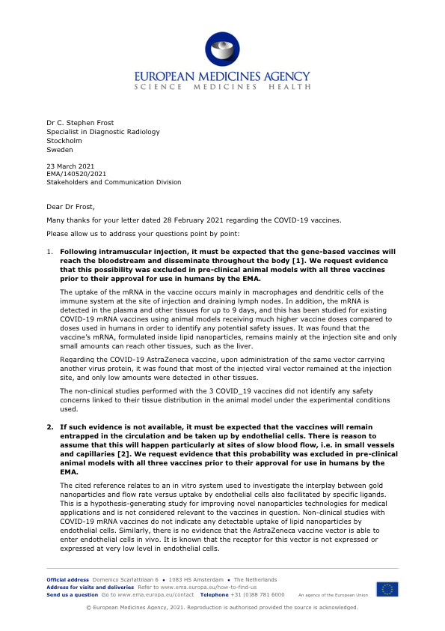

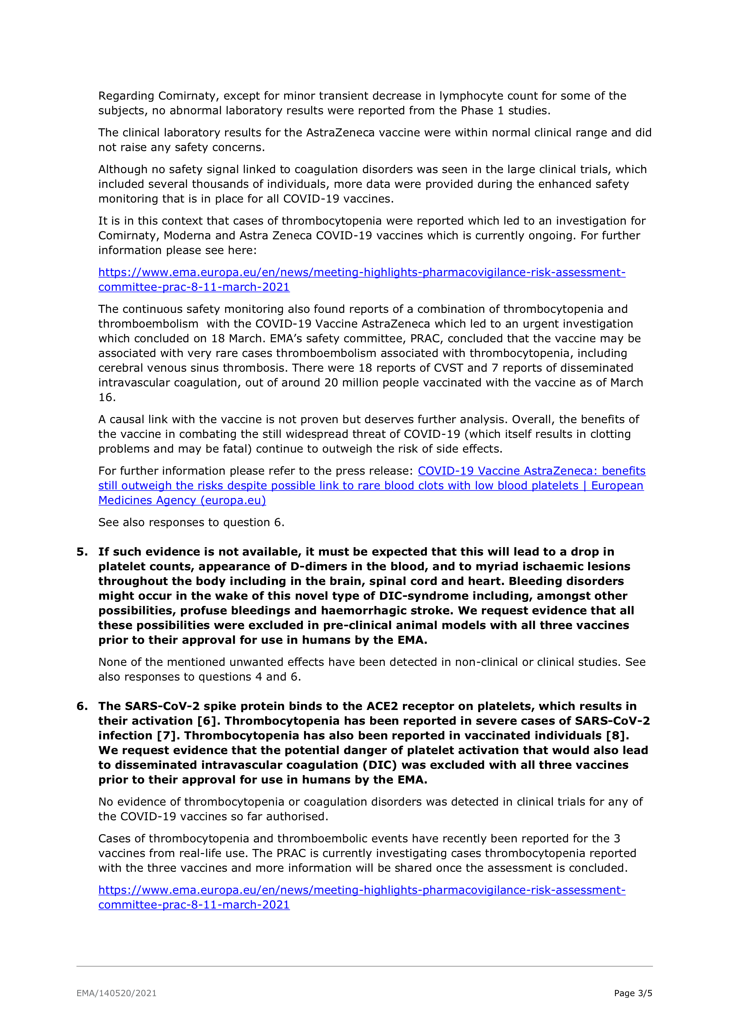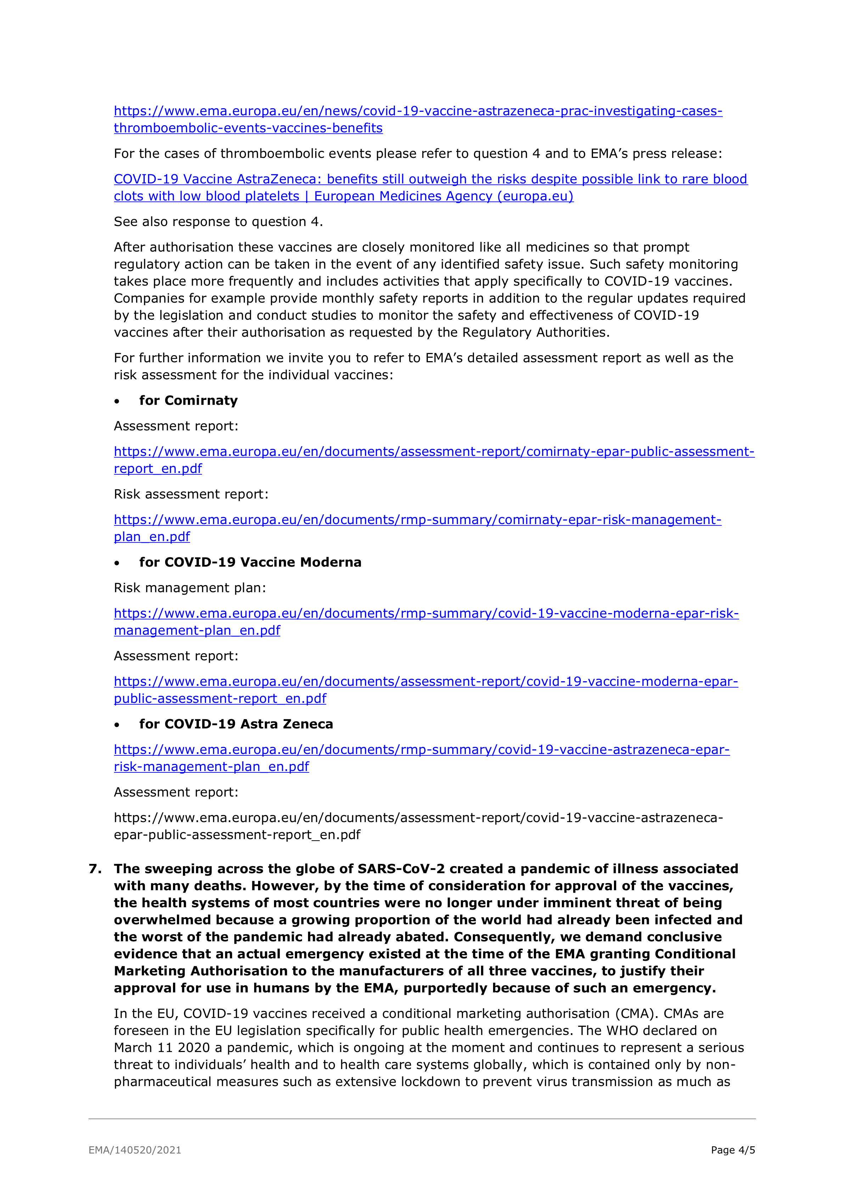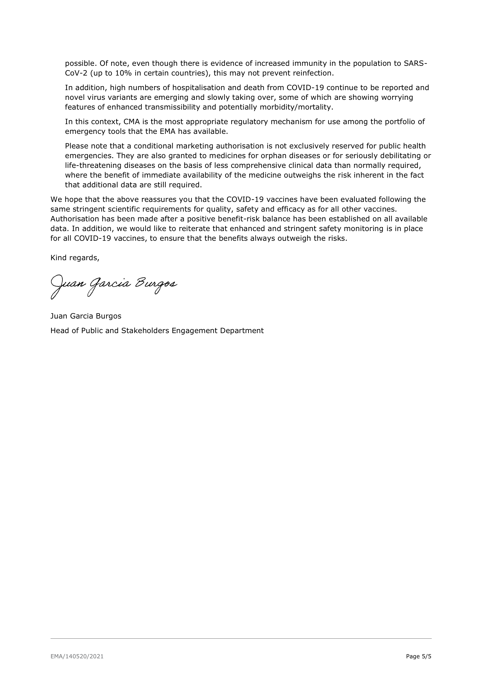

APPENDIX III

Doctors and Scientists Accuse Medical Regulator of Downplaying COVID-19 Vaccine Dangers

PRESS RELEASE - FOR IMMEDIATE RELEASE

**Doctors and Scientists Accuse Medical Regulator of Downplaying COVID-19 Vaccine Dangers**

The European Medicines Agency is misleading citizens into medical experimentation, experts warn

April 1st 2021

Doctors and scientists from 25 countries have today issued a [rebuttal letter](https://doctors4covidethics.medium.com/rebuttal-letter-to-european-medicines-agency-from-doctors-for-covid-ethics-april-1-2021-7d867f0121e) to the European Medicines Agency (EMA), following the regulator’s dismissal of their earlier warnings regarding COVID-19 vaccine dangers from clotting and bleeding.

Within days of the EMA receiving the group’s [original letter](https://doctors4covidethics.medium.com/urgent-open-letter-from-doctors-and-scientists-to-the-european-medicines-agency-regarding-covid-19-f6e17c311595) on March 1st, outlining risks of blood disorders from COVID-19 vaccines, over a dozen countries suspended the AstraZeneca vaccine following deaths from clotting and bleeding, as the doctors had warned.

On March 23rd, however, the EMA [dismissed](https://doctors4covidethics.medium.com/reply-from-the-european-medicines-agency-to-doctors-for-covid-ethics-march-23-2021-d6760984dd06) the group’s concerns as relating to “minor” and “rare” events, concluding that “a positive benefit-risk balance has been established.”

The doctors and scientists have today hit back, accusing the EMA of misleading the public on the vaccines’ true risk-benefit profile. “Your reply of March 23 is unconvincing and unacceptable,” they wrote, noting that recorded cases of life-threatening cerebral venous thrombosis (CSVT) post-vaccination likely “represent just the tip of a huge iceberg”. Common reactions to vaccination, including headache, nausea, blurred vision and vomiting, they state, are symptoms of CSVT, and should be assessed as such, immediately.

Clotting and bleeding after vaccination can also “be expected to increase with each re-vaccination, and each intervening coronavirus exposure” the group warned. Over time “this renders both repeated vaccination and common coronaviruses dangerous to young and healthy age groups, for whom - in the absence of ‘vaccination’ - COVID-19 poses no substantive risk.

“Such is the real risk-benefit analysis of the COVID-19 ‘vaccines’. Either the EMA lacks the subject-matter expertise to appreciate the molecular science of this reality, or it lacks the medical ethics to act accordingly.”

The group, Doctors for Covid Ethics, which includes professors of immunology and microbiology, described the EMA’s responses to their concerns as “unscientific”, “vague”, and lacking credibility. They have offered to liaise with the agency to mitigate against vaccination risks and ethics violations, including helping the EMA to “craft a focussed pharmacovigilance plan.”

The group warned that continuing to administer inadequately tested gene-based COVID-19 vaccines represents dangerous medical experimentation, whose “true risks far outweigh any theoretical benefits”, reflecting “serious violations of medical ethics and citizens’ medical rights.”

“Misleading populations into accepting investigational agents such as the gene-based COVID-19 ‘vaccines’, or coercing them through ‘vaccine passports’, constitutes clear and egregious violations of the Nuremberg Code”, they caution.

The letter is addressed to Emer Cooke, Executive Director of the EMA, and was copied to the lawyer Reiner Fuellmich, Charles Michel, President of the Council of Europe, and Ursula von der Leyen, President of the European Commission.

Link to Doctors for Covid Ethics rebuttal letter to EMA (April 1st): <https://doctors4covidethics.medium.com/rebuttal-letter-to-european-medicines-agency-from-doctors-for-covid-ethics-april-1-2021-7d867f0121e>

Link to EMA letter to Doctors for Covid Ethics (March 23rd): <https://doctors4covidethics.medium.com/reply-from-the-european-medicines-agency-to-doctors-for-covid-ethics-march-23-2021-d6760984dd06>

Doctors for Covid Ethics is a group of over 100 doctors and scientists from 25 countries.

Web: <https://doctors4covidethics.medium.com>

Twitter: <https://twitter.com/Drs4CovidEthics>

For comment contact Professor Sucharit Bhakdi MD: [sucharit.bhakdi@gmx.de](mailto:sucharit.bhakdi@gmx.de) or Associate Professor Michael Palmer MD: [mpalmer@uwaterloo.ca](mailto:mpalmer@uwaterloo.ca)

**Further resources**

Original Doctors for Covid Ethics letter to EMA (Delivered March 1st): <https://doctors4covidethics.medium.com/urgent-open-letter-from-doctors-and-scientists-to-the-european-medicines-agency-regarding-covid-19-f6e17c311595>

Video statement (March 11th) by Professor Sucharit Bhakdi, Professor Emeritus of Medical Microbiology and Immunology and Former Chair, Institute of Medical Microbiology and Hygiene: <https://lbry.tv/@Doctors4CovidEthics:d/Prof.-Sucharit-Bhakdi-statement-on-EMA-open-letter.ENG:0>

Doctors, scientists, lawyers and colleagues in allied disciplines can sign the open letter by sending their name, qualifications, areas of expertise and country of practice to: [Doctors4CovidEthics@protonmail.com](mailto:Doctors4CovidEthics@protonmail.com), with web verification (eg workplace or registration link, not for publication).

END

###

APPENDIX IV

Rebuttal Letter to European Medicines Agency from Doctors for Covid Ethics

From Doctors for Covid Ethics

Emer Cooke

Executive Director

European Medicines Agency

Amsterdam

The Netherlands

April 1st 2021

Ladies and Gentlemen,

**FOR THE URGENT PERSONAL ATTENTION OF: EMER COOKE, EXECUTIVE DIRECTOR OF THE EUROPEAN MEDICINES AGENCY**

We acknowledge receipt of your March 23 reply to our letter dated February 28,seeking reassurance that foreseeable risks of gene-based COVID-19 “vaccines” had been ruled out in animal trials prior to human use. Our concerns arise from multiple lines of evidence, including that the SARS-CoV-2 “spike protein” is not a passive docking protein, but its production is likely to initiate blood coagulation via multiple mechanisms.

Regrettably, your reply of March 23 is unconvincing and unacceptable. We are dismayed that you choose to respond to our request for crucially important information in a dismissive and unscientific manner. Such a cavalier approach to vaccine safety creates the unwelcome impression that the EMA is serving the interests of the very pharmaceutical companies whose products it is your pledged duty to evaluate. The evidence is clear that there are some serious adverse event risks & that **a number of people, not at risk from SARS-CoV-2, have died following vaccination.**

1. You concede that the “vaccines”, which are more accurately described as investigational gene-based agents, enter the bloodstream but you can obviously provide no quantitative data. In the absence of the latter, any scientific assessment you purport to have undertaken lacks foundation.
2. Your statement that non-clinical studies do not indicate any detectable uptake of the vaccines into endothelial cells lacks credibility. We demand to see the scientific evidence. If not available, it must be assumed that endothelial cells are targeted.
3. Auto-attack could not have been excluded in animals unless they had been immunologically primed beforehand. We demand evidence that such experiments had been performed. Similar experiments have been undertaken before with previous, unsuccessful candidate vaccines, and fatal, antibody-dependent enhancement of disease was observed.
4. We requested scientific evidence, not a vague description of what was purportedly seen in non-valid animal experiments. Your cursory mention of laboratory findings in humans is cynical. In view of the plausible connection between production of spike protein and the emergence of thromboembolic serious adverse events (SAEs), we demand to see the results of D-dimer determinations. As you are aware, D-dimer is a very good test as an aid to diagnose thrombosis.

After delivery of our letter to you on March 1, events followed that debunk your response to our last three queries to an extent that can only be termed embarrassing. As we feared, severe and fatal coagulopathies occurred in young individuals following “vaccination”, leading 15 countries to suspend their AZ-“vaccination” program. An official investigation by the EMA into the cases of afflicted younger individuals followed, the results of which were announced by the WHO on March 17, 2021, stating: “At this time, WHO considers that the benefits of the AstraZeneca vaccine outweigh its risks and recommends that vaccinations continue.”

What was this decision based upon? The WHO is not a competent body for formally evaluating drug safety. That is explicitly the role of the agency you lead.

In your press release, you disclosed the following information to support your conclusion. You had scrutinized data on two mortally dangerous conditions that had followed within 14 days of “vaccination”: DIC, disseminated intravascular coagulation; and CSVT, cerebral sinus vein thrombosis. 5 DIC and 18 CSVT were on record, with a total death toll of 9. Most cases were <55 year-old individuals. 5 DIC and 12 CSVT were under 50 years of age. None were reported as having had serious pre-existing illness.

You stated numbers that “normally” would be expected : DIC <1, CSVT 1.3.

Consequently, for these very rare conditions, a link to vaccination could not entirely be dismissed. However, given that 20 million individuals had been “vaccinated”, the benefits were deemed to far outweigh the risks.

**But in fact, your Press Release rendered it glaringly apparent that the AZ-“vaccine” does have the potential to trigger intravascular coagulation, that the true risks far outweigh any theoretical benefits, and that any authority with the slightest sense of responsibility must suspend its further use.**

1. Regard your incidence numbers for <50 year old individuals in the “vaccinated” versus “normal” population:

**CSVT : 12 versus 1.3.**

**A 9-fold increase is beyond the range of coincidence.**

**DIC : 5 versus <1.**

**As we hope you know, DIC *never* occurs out of the blue in healthy individuals. The incidence should not be stated as <1 when in reality it is ZERO.**

**ACCORDINGLY, THE DIC CASES REPRESENT *CONCLUSIVE* EVIDENCE THAT THE AZ-VACCINE *ALONE* CAN TRIGGER INTRAVASCULAR COAGULATION .**

1. Assume that 10 million recipients of the “vaccine” were < 60 yrs and this was followed by 9 deaths due to DIC and SVCT. The death toll upon 60 million “vaccinations” would be extrapolatable to 54.

The pandemic hit around 60 million individuals < 60 yrs in Germany.

During the first 6 months it reportedly claimed 52 lives of individuals without pre-existing illness.

(<https://www.rki.de/DE/Content/Gesundheitsmonitoring/JoHM/2020/JoHM_Inhalt_20_S11.html>)

Because of the unreliability of PCR testing and because of the completely novel way that deaths ‘with covid19’ are determined, the value of 52 is an over-estimate of the real burden of disease, further weakening your already-inadequate claim for risk-benefit.

How, then, can you declare that the benefits of vaccination far outweigh the risks? We demand your reply supported by facts and figures that we will convey to the public.

1. Further considerations expose the truly frightful dimensions of your irresponsible assertion.

CSVT, cerebral venous thrombosis, is **always** a life-threatening condition that demands immediate medical attention. The number of cases you conceded had occurred can represent just the tip of a huge iceberg. As you must know, the most common symptoms of CSVT are piercing headache, blurred vision, nausea and vomiting. In severe cases, stroke-like symptoms occur including impairment of speech, vision and hearing, body numbness, weakness , decreased alertness and loss of motoric control.

Surely, you are not oblivious to the fact that countless individuals suffered from precisely such symptoms directly following “vaccinations” with **all** the experimental gene-based agents.

Clot formation in deep leg veins can lead to lethal pulmonary embolisms. Surely you must know that peripheral venous thromboses have repeatedly been reported following “vaccinations” with **all** the experimental gene-based agents

Microthromboses in the lung vasculature can lead to misdiagnosis of pneumonia. In combination with false-positive PCR (with high cycle thresholds), these will then be registered as COVID 19 cases. Surely you must know that this scenario has probably repeatedly taken place following “vaccinations” with **all** the experimental gene- based agents.

In all events, extensive thrombi formation can lead to consumption of platelets and coagulation factors, resulting in hemorrhagic diathesis and bleeding at all possible locations. Surely you must know that profuse skin bleedings have repeatedly been observed following “vaccinations” with **all** the experimental gene-based agents.

Given that there is a mechanistically plausible explanation for these thromboembolic adverse drug reactions (TE ADRs), namely that the gene-based products induce human cells to manufacture potentially pro-thrombotic spike protein, the reasoned & responsible assumption must now be that this may be a class effect. In other words, the dangers must be ruled out for all emergency-authorised gene-based vaccines, not merely the AZ product.

We urge you to adopt this stance unless and until there is data providing high clinical confidence to the contrary. We are very willing to liaise with the Agency in order to help craft a focussed pharmacovigilance plan to accomplish this goal. With the above in mind, we hope you are aware that all thrombotic events can be rapidly diagnosed by measurement of D-Dimers in blood. And that good medical practice imperatively demands that attempts are undertaken to diagnose CSVT in any and every patient, young or old, presenting with the typical signs and symptoms following “vaccination”.

Given the potential for adverse effects, potentially fatal ones, it is completely inappropriate and unacceptable that EMA permits these products, which hold only emergency use authorisations, to be administered to younger (<60y) people who are healthy, as they are at unmeasurable risks from SARS-CoV-2.

Not to make this explicit is, in our view, a reckless stance to have taken in the first place and doubly so now.

Of equal importance, you are bound by duty to investigate whether reasons exist for the waves of deaths that have occurred following “vaccination” of elderly residents in care and senior homes. Or are you asserting that dangers of “vaccine”-derived thrombotic events are limited to younger individuals? If not, restricting their use solely in one age group – as decided upon in Germany – equates with nothing less than monstrous, condoned genocide of the other.

In closing, failure to inform “vaccine” recipients of the risks and negligible benefits outlined here represents serious violations of medical ethics and citizens’ medical rights. Those violations are especially grave as all the risks we describe can be expected to increase with each re-vaccination, and each intervening coronavirus exposure. This renders both repeated vaccination and common coronaviruses dangerous to young and healthy age groups, for whom - in the absence of “vaccination” - COVID-19 poses no substantive risk.

Such is the real risk-benefit analysis of the COVID-19 “vaccines”. Either the EMA lacks the subject-matter expertise to appreciate the molecular science of this reality, or it lacks the medical ethics to act accordingly.

At best, we regard the EMA’s complacent stance on vaccine dangers to be symptomatic of the fact that, under the prevailing politico-medical response to COVID-19, medical ethics has migrated from the consulting room to a geopolitical stage. Faced with a medical problem, mass-medical intervention has seen the practice of medicine taken from doctors’ hands. In this politicized context, corporate and political actors may consider themselves free from ethical constraints, operating unbound by a medical code of ethics, unlike medical doctors. All actors, however, are bound by the Nuremberg Code.

The Nuremberg Code prohibits human experimentation of the very kind being endorsed and defended by the EMA. Even under the terms of their own original FDA authorization, COVID-19 vaccines are deemed “investigational” and their recipients “human subjects”, who are, by definition, entitled to informed consent.  [https://www.fda.gov/regulatory-information/search-fda-guidance-documents/emergency-use-investigational-drug-or-biologic#:~:text=Emergency%20use%20is%20defined%20as,21%20CFR%2056.102(d)%5D](https://www.fda.gov/regulatory-information/search-fda-guidance-documents/emergency-use-investigational-drug-or-biologic" \l ":~:text=Emergency%20use%20is%20defined%20as,21%20CFR%2056.102(d)%5D" \t "_blank).

Misleading populations into accepting investigational agents such as the gene-based COVID-19 “vaccines”, or coercing them through “vaccine passports”, constitutes clear and egregious violations of the Nuremberg Code. The Nuremberg Code mandates voluntary informed consent “without the intervention of any element of force, fraud, deceit [or] duress”. <https://history.nih.gov/display/history/Nuremberg+Code>

In other words, citizens have the right under the Nuremberg Code and related protections not to be subject involuntarily to medical experiments. It is clear that **these experimental agents should be CONTRA-INDICATED in individuals not at elevated risk of serious illness & death if infected by SARS-CoV-2**. Furthermore, the use of the experimental agents must also be withheld in the elderly population until a risk-benefit assessment has been properly conducted. In any event, the vaccine label must be revised to reflect the recently emerged serious adverse events addressed here.

We remind the EMA that Nuremberg violations constitute crimes against humanity under the Geneva Convention. Crimes against humanity are deemed “the worst atrocities known to mankind”, and are prosecuted under the Rome Statute of the International Criminal Court. <https://www.un.org/en/chronicle/article/role-international-criminal-court-ending-impunity-and-establishing-rule-law>

Given the hundreds of millions and eventually billions of people who may be coerced into accepting these agents, the EMA, in persistently shrinking from open debate and the truth, will be seen by lawyers and historians as having actively assisted in crimes against humanity, with the full weight of the implications to all involved. We demand that you engage openly with us to ensure that the public have an objective understanding of the clinical risk profile of these gene-based interventions.

You understand that coercive pressure is being placed on citizens to receive COVID-19 vaccines, which are experimental medical treatments. Your responsibility to those citizens includes ensuring that they are informed of the adverse event risks of every such treatment. To date you have failed to do so, and have instead misled the public on the reality of the “vaccines’” risk-benefit profile.

If you continue to conceal the truth, efforts will be made to bring this to light and to see that justice is done. For the sake of the injured and the dead, and to protect further lives from similar fates.

**NOTICE**

For the avoidance of doubt, if your regulatory body does not immediately suspend its "emergency" recommendation of potentially dangerous inadequately tested gene-based "vaccines", while the matters which we have highlighted to you are properly investigated, we hereby put the European Medicines Agency on notice of being complicit in medical experimentation, in violation of the Nuremberg Code, which thereby constitutes the commission of crimes against humanity.

Furthermore, it is your indirigible duty as a regulatory body to ensure that all doctors worldwide are advised that they are taking part in medical experimentation via "vaccination" programmes, whether wittingly or unwittingly, with all the legal and ethical obligations that such involvement entails.

This email is copied to the lawyer Reiner Fuellmich. It is also copied to Charles Michel, President of the Council of Europe, and to Ursula von der Leyen, President of the European Commission.

Yours faithfully,

Doctors for Covid Ethics

Over 100 doctors and scientists from 25 countries <https://doctors4covidethics.medium.com/urgent-open-letter-from-doctors-and-scientists-to-the-european-medicines-agency-regarding-covid-19-f6e17c311595>

APPENDIX V

Doctors for Covid Ethics Signatories

**Doctors for Covid Ethics Signatories**

Doctors for Covid Ethics has written two open letters to the European Medicines Agency regarding COVID-19 vaccine dangers. In those letters we have insisted upon evidence that risks of clotting, bleeding and platelet abnormalities were appropriately ruled out in legitimate empirical trials prior to human use.

Signatories across the two letters are as follows:

**Founding signatories**

Professsor Sucharit Bhakdi MD, Professor Emeritus of Medical Microbiology and Immunology, Former Chair, Institute of Medical Microbiology and Hygiene, Johannes Gutenberg University of Mainz (Medical Doctor and Scientist) (Germany and Thailand)

Dr Marco Chiesa MD FRCPsych, Consultant Psychiatrist and Visiting Professor, University College London (Medical Doctor) (United Kingdom and Italy)

Dr C Stephen Frost BSc MBChB, Specialist in Diagnostic Radiology, Stockholm, Sweden (Medical Doctor) (United Kingdom and Sweden)

Dr Margareta Griesz-Brisson MD PhD, Consultant Neurologist and Neurophysiologist (studied Medicine in Freiburg, Germany, speciality training for Neurology at New York University, Fellowship in Neurophysiology at Mount Sinai Medical Centre, New York City; PhD in Pharmacology with special interest in chronic low level neurotoxicology and effects of environmental factors on brain health), Medical Director, The London Neurology and Pain Clinic (Medical Doctor and Scientist) (Germany and United Kingdom)

Professor Martin Haditsch MD PhD, Specialist (Austria) in Hygiene and Microbiology, Specialist (Germany) in Microbiology, Virology, Epidemiology/Infectious Diseases, Specialist (Austria) in Infectious Diseases and Tropical Medicine, Medical Director, TravelMedCenter, Leonding, Austria, Medical Director, Labor Hannover MVZ GmbH (Medical Doctor and Scientist) (Austria and Germany)

Professor Stefan Hockertz, Professor of Toxicology and Pharmacology, European registered Toxicologist, Specialist in Immunology and Immunotoxicology, CEO tpi consult GmbH. (Scientist) (Germany)

Dr Lissa Johnson, BSc BA(Media) MPsych(Clin) PhD, Clinical Psychologist and Behavioural Scientist, Expertise in the social psychology of atrocity, torture, collective violence and propaganda, former professional body Public Interest Advisory Group member (Psychologist) (Australia)

Professor Ulrike Kämmerer PhD, Associate Professor of Experimental Reproductive Immunology and Tumor Biology at the Department of Obstetrics and Gynaecology,

University Hospital of Würzburg, Germany, Trained molecular virologist (Diploma, PhD- Thesis) and Immunologist (Habilitation), Remains engaged in active laboratory research (Molecular Biology, Cell Biology) (Scientist) (Germany)

Associate Professor Michael Palmer MD, Department of Chemistry (studied Medicine and Medical Microbiology in Germany, has taught Biochemistry since 2001 in present university in Canada); focus on Pharmacology, metabolism, biological membranes, computer programming; experimental research focus on bacterial toxins and antibiotics (Daptomycin); has written a textbook on Biochemical Pharmacology, University of Waterloo, Ontario, Canada (Medical Doctor and Scientist) (Canada and Germany)

Professor Karina Reiss PhD, Professor of Biochemistry, Christian Albrecht University of Kiel, Expertise in Cell Biology, Biochemistry (Scientist) (Germany)

Professor Andreas Sönnichsen MD, Professor of General Practice and Family Medicine, Department of General Practice and Family Medicine, Center of Public Health, Medical University of Vienna, Vienna (Medical Doctor) (Austria)

Dr Wolfgang Wodarg, Specialist in Pulmonary and Bronchial Internal Medicine, Hygiene and Environmental Medicine, Epidemiology, and Public Health; Honorary Member of the Parliamentary Assembly of the Council of Europe and former Head of the Health Committee of the Parliamentary Assembly of the Council of Europe; former Member of Parliament, German Bundestag; Initiator and Spokesman for the study commission ‘Ethics and Law in Modern Medicine’; Author and University Lecturer (Medical Doctor) (Germany)

Dr Michael Yeadon BSc (Joint Honours in Biochemistry and Toxicology) PhD (Pharmacology), Formerly Vice President & Chief Scientific Officer Allergy & Respiratory, Pfizer Global R&D; Co-founder & CEO, Ziarco Pharma Ltd.; Independent Consultant (Scientist) (United Kingdom)

**Endorsing signatories**

Dr Reem Abu-Sbaih, DO, Doctor of Osteopathy, Associate Professor Osteopathic Manipulative Medicine/ Neuromusculoskeletal Medicine (Medical Doctor) (USA)

Dr Adriana Reyes Agudelo, MD, Surgeon (Medical Doctor) (Spain) Dr Véronique Ahari, General Practitioner (Medical Doctor) (France)

Dr Maria José Martínez Albarracín, Bachelor of Medicine and Surgery, Physician and Professor of Clinical Diagnostic Processes, Specialized in Clinical Analysis (Medical Doctor) (Spain)

Dr Alicja Alda, General Practitioner and Ear Nose and Throat specialist (Medical Doctor) (Norway)

Dr Fernando Ania, ND, Naturopathic Doctor (Canada)

Dr Carmen Soler Arnedo, Surgeon, General Medicine (Medical Doctor) (Spain)

Dr Mario Cabrera Avivar, MD, Specialist in Public Health, former Consultant to the Pan American Health Organisation, the World Health Organisation Regional Office for the Americas (OPS/OMS) (Medical Doctor) (Uruguay)

Rena Bartolettti, Pharmacist, previously of the General Pharmacy Inspectorate, Registration Service Medicines, Federal Public Health and Safety Authority (Pharmacist) (Belgium)

Dr Gabriela Bachmann, General Medicine, Specialising in children and young people (Medical Doctor) (Austria)

Dr. Elizabeth Bastian, BSc (Genetics and Microbiology), MDCM, Family Medicine, General Practitioner in Oncology, sub specialty trained in Palliative Care (Medical Doctor) (Canada)

Dr Pedro López Bastido, Stomatologist (Medical Doctor) (Spain)

Dr Michael D Bell, MB, ChB (1978 Edinburgh) MRCGP (1989), General Practitioner (Medical Doctor) (United Kingdom)

Rev. Reuben P. Bell, DO, MS, MDiv, PhD, Osteopathic family physician since 1982, Bachelors and Masters degrees in Zoology, formerly Professor of Biology (including Molecular Genetics and Developmental Biology), M.Div. and Ph.D. in theological studies, with attention to issues of science and religion (Medical Doctor and Scientist) (USA)

Dr Francisco Lacruz Bescos, MD, PhD, Consultant Neurologist with special training and dedication to Neuroimmunology and Multiple Sclerosis (Retired) (Medical Doctor) (Spain)

Dr Thomas Binder, MD, specialised in Cardiology and Internal Medicine, thesis in Immunology and Virology, with 32 years experience in diagnosis and treatment of Acute Respiratory Illness (Medical Doctor) (Switzerland)

Sarah Binns, MA VetMB, MS, MRCVS, MSc, PhD, DipLSHTM, Former Veterinary Infectious Disease Epidemiologist (United Kingdom)

Dr Rainer Bliefert, Dentist (Switzerland)  
Dr Michael Brandner, Dr. Med. (Medical Doctor) (Germay)

Dr Rachel Brown, MBChB, LLM (Medical Law & Ethics), MRCPsych CFMP, Consultant Psychiatrist (Medical Doctor) (United Kingdom)

Dr Roxana Bruno, PhD in Immunology, Researcher in Biochemistry, Immunology, Neuroinmunology and Genetics (Scientist) (Argentina)

Dr Elizabeth Burton, MBChB, General Medical Practitioner (Retired)(Medical Doctor) (United Kingdom)

Dr Natalia Prego Cancelo, MD, Community and Family Medicine Specialist, founder of “Médicos por la Verdad” (Doctors for the Truth) worldwide, platform of doctors in more than 17 countries (Medical Doctor) (Spain)

Dr Ronald S. Carlson, AB Chem/Bio, DDS, Dentist (USA)  
Dr Rafael Reinoso Casado, Family and Community Medicine (Medical Doctor) (Spain)

Dr Vernon Coleman, MB, ChB, General Practice Principal (Retired) (Medical Doctor) (United Kingdom)

Isabella Cooper, BSc (Hons) Biochemistry, AFHEA, AMRSB, AfENDO, Doctoral Researcher, Areas of expertise: hyperinsulinaemia, disseminated intravascular coagulability, mitochondrial molecular biology and cancer metabolism (Scientist) (United Kingdom)

Dr Johan Corthouts, General Practitioner (Medical Doctor) (Belgium)

Jonathan Jay Couey, Assistant Professor of Research, Pitt School of Medicine Research Faculty, Department of Neurobiology, examining cortical and subcortical microcircuits using promotor/enhancer driven gene expression (Scientist) (USA)

Dr David Critchley, BSc, PhD, Clinical Research Scientist with more than 30 years experience, including projects in Virology and Immunology (Scientist) (United Kingdom)

Professor Barbara A Crothers, DO, Associate Professor, Pathology, Gynecologic, Breast and Cytopathology (USA)

Dr Rita Darby, General Practitioner (Medical Doctor) (Wales)

Dr. Daniel de la Torre Llorente, Biology Professor, Biotechnology-Plant Biology Department, Agronomic, Food and Biosystems Engineering School (ETSIAAB) Universidad Politécnica de Madrid (Scientist) (Spain)

Dr John Day, MD, Family Medicine (Board certified since 1990) (Medical Doctor) (USA) Dr Hilde De Smet, General Practitioner (Medical Doctor) (Belgium)  
Dr Johan Denis, General Practitioner (Medical Doctor) (Belgium)  
Dr Steven Depicker, General Practitioner (Medical Doctor) (Belgium)

Dr M. Doesburg-van Kleffens, MSc, PhD, Specialist in Laboratory Medicine (Clinical Chemistry), of Stichting Artsen Covid Collectief, an independent Dutch Collective of Medical Professionals (Scientist) (The Netherlands)

Dr Geanina Dragnea, Obstetrician-Gynecologist (Medical Doctor) (Romania)

Dr Nyjon Eccles, BSc, MBBS, MRCP, PhD, Specialist in Functional & Environmental Medicine (Medical Doctor) (United Kingdom)

Dr Karin Eisfeld, Molecular Biologist, Senior Regulatory Affairs Manager in the approval of new drugs and medical devices (Scientist) (Germany)

Dr Blanca Assumption Lario Elboj, Specialsit in Ophthalmology (Medical Doctor) (Spain)

Dr Kjetil H. Elvevold, Senior Scientist, worked as Senior Scientist in a Contract Research Organization (CRO) in Norway that performed pre-clinical experiments for the pharmaceutical industry (Scientist) (Norway)

Dr Andreas Emmert, Specialist in Microbiology, Head Physician at Østfold Regional Hospital, Norway (Medical Doctor) (Norway)

Merit Enckell, Civ. Ing, PhD, Independent researcher, Structural Health Monitoring and Emerging Technologies, Formerly of KTH Royal Institute of Technology (Scientist) (Sweden)

Dr Sonia Andrés Espallardo, Psychiatrist (Medical Doctor) (Spain)

Dr Radimé Farhumand, Specialist in Anesthesia (Medical Doctor) (Germany)

Dr Thomas Faulkner, MChiro, DC, Managing Director and Chiropractor (United Kingdom)

Dr Susan Flett, Specialist in Psychiatry, Child Psychiatry and Psychotherapy (Semi- retired) (Medical Doctor) (United Kingdom)

Dr Konstantinos Fountzoulas, MD, PGDiP Orth Eng., FEBOT, FRCS (Tr & Orth), Consultant Trauma and Orthopaedic Surgeon (Medical Doctor) (England and Italy)

Dr Paul Christian Friedl, Ophthalmologist (Medical Doctor) (Austria)

Dr Carrie Ganek, MD, Adult Psychiatry (Medical Doctor) (USA)

Dr Martin E Ganek, MD, Board Certified Paediatrician (Medical Doctor) (USA)

Dr Emanuel E. Garcia, MD (University of Pennsylvania School of Medicine, 1986), Psychiatrist (Medical Doctor) (USA)

Dr Parisi Giovanni, Specialist in Ophthalmology and Sports Medicine (Medical Doctor) (Italy)

Dr Hartmut Glossmann, Professor Emeritus, Doctor of Medicine and Specialist in Pharmacology / Clinical Pharmacology, Institute for Biochemical Pharmacology, Innsbruck (Medical Doctor and Scientist) (Germany)

Amparo de Luque González, Dentist (Spain)

Dr Céline Guérin, PhD in Neurosciences, Master in Microbiology and Genetics (Scientist- Practitioner) (France)

Dr. Olga Petrovna Guzova, Pediatrician, Dermatologist and Dermatopathologist (Medical Doctor) (Panama)

Dr Hans-Michael Hackenberg, Family Doctor and Sports Medicine Specialist (Retired) (Medical Doctor) (Germany)

Dr Roman Häussler, General Medicine (Austria)

Dr Jutta Heinrich-Nols, Doctor and Clinical Pharmacologist (Medical Doctor and Scientist) (Germany)

Julie Henrotte, Quality System Expert, 12+ years in GSK Pharma (Scientist) (France)

Dr Angel Ruiz-Valdepeñas Herreros, Bachelor of Medicine, Licenciado en Medicina por la Universidad de Murcia, Specialist in Family and Community Medicine, co-founder of “Médicos por la Verdad” (Doctors for the Truth) worldwide, platform of doctors in more than 17 countries (Medical Doctor) (Spain)

Dr Birgit Hörger, Resident Doctor, Specialist in General Medicine (Medical Doctor) (Germany)

Dr April M. Hurley, MD, Family Physician for 35 years (Medical Doctor) (USA)

William Ip, BSc. MIBMS, Former NHS Biomedical Scientist (Specialist in Microbiology), for over 30 years (Sicentist) (United Kingdom)

Dr Hervé Janecek, Veterinarian (France)

Jerzy Jaskowski, MD, PhD, MS, Specialties in General Surgery, Environmental Medicine, Physics and Biophysics (Retired)(Medical Doctor and Scientist) (Poland)

Dr. Elisabeth Jenik, General Medicine, Occupational Medicine and Psychosomatic Medicine (Medical Doctor) (Austria)

Dr Alain Joseph, General Medicine Specialist (Retired) (Medical Doctor) (France)

Dr Konstantinos Kakleas, MD, MRCPCH, MSc, PhD, Paediatric Allergy Consultant, Leicester Royal Infirmary Hospital (Medical Doctor) (United Kingdom)

Dr Hootan Kazemi, BDS Dental Surgeon, MSc(Distinc.) Clinical Biochemistry, BSc(Hons) Physiology (General Dental Practitioner) (United Kingdom)

Dr Ingrid Kiesel, Specialist in Psychiatry, Psychotherapy and General Medicine (Medical Doctor) (Germany)

Dr Alina Kislich, General Practitioner, Graduated from the Medical University of Vienna (Medical Doctor) (Austria)

Dr Wiltrud Kling, Specialist in General Medicine (Medical Doctor) (Germany)  
Dr Ewa Konik, MD, Heart Transplant Cardiologist (Medical Doctor) (USA)  
Dr Doris Krien, Assistant Doctor, Günzburg District Hospital (Medical Doctor) (Germany)

Brigitte Lacroix, clinical PKPD and PBPK modeler (Pharma industry), PhD in Pharmacy (Paris XI University), PhD in Pharmacometrics (Uppsala University) (Scientist) (France, Sweden)

Dr Andreas Lang, MD (Medical Doctor) (Germany)

Dr Paul Laursen, PhD, Adjunct Professor, AUT University (Scientist) (New Zealand and Canada)

Dr Michael S Lavender, Consultant Anaesthetist (Medical Doctor) (Australia)

Dr Tess Lawrie, MBBCh, PhD, Guideline methodologist and evidence synthesis expert, Director of The Evidence Based Medicine Consultancy Ltd, Bath UK. Honorary Researcher at the Royal United Hospital, Bath UK (Medical Doctor and Scientist) (United Kingdom)

Dr Bronia Lee, MBBCh, MRCGP, Retired General Practitioner (Medical Doctor) (United Kingdom)

Dr Katrina Lewis, MD, BSc in Immunology and Physiological Chemistry, triple Board certified ( USA) in Anesthesiology, Pain Medicine and Functional Medicine (Medical Doctor) (South Africa, USA)

Dr Derek Lohan, Consultant Radiologist and Director, Helix Radiology (Medical doctor) (Ireland)

Dr Ricardo Arriola López, General Medicine, (Medical Doctor) (Spain) Dr. Adele Lorigan, BSC (Chiro), Chiropractor (Australia)  
Dr Antje Lueg, Specialist in Ophthalmology (Medical Doctor) (Germany)

Dr. Thomas Ly, MD, Infectologist and Paediatrician, Specialized in Tropical Medicine, Head of MedicalQM, a think tank on medical quality management and patient safety, Founder of the upcoming International Institute for Human Pathogenic Infectious Diseases “InfectCore” (Medical Doctor) (Germany and Thailand)

Dr Kulvinder S. Manik, MBChB, MA, LLM, MRCGP, GP (Medical Doctor) (England)

Dr. Rosemarie Mayr, Specialist in Psychiatry and Psychotherapeutic Medicine and Child and Adolescent Psychiatry, ÖÄK Diploma for Homeopathy (Retired) (Medical Doctor) (Germany)

Dr Nathi Mdladla, Associate Professor and Chief of ICU, Dr George Mukhari Academic Hospital and Sefako Makgatho University (Medical Doctor) (South Africa)

Dr Janet Menage, MA, MB, ChB, General Medical Practitioner (Retired) Qualified Psychological Counsellor (Medical Doctor) (United Kingdom)

Dr Niall McCrae, PhD, MSc, RMN, Mental health researcher, Psychiatric Nurse (United Kingdom)

Professor Nathalie McDonell, MD, PhD (human genetics), Professor of Molecular and Cell Biology (Medical Doctor and Scientist) (France)

Dr Ciaran Montague, MVB, MRCVS, Royal College of Veterinary Surgeons certified veterinary dermatologist with 25 years general and referral practice (Veterinarian) (N. Ireland)

Dr Sabine de Monvallier, General Practitoner (Medical Doctor) (France) Dr Amir Mortasawi, Physician and author (Germany)

Dr Jens Münch, Neurologist, Psychoanalyst and Specialist in Psychosomatic Medicine and Trauma (Medical Doctor) (France)

Dr. Graeme Munro-Hall, BDS, Dentist (retired), pioneered the use of glutathione with vitamin C, awarded a Fellowship of the International Academy of Oral Medicine and Toxicology in 1996 (Dentist) (United Kingdom)

Dr Souha Nasreddine, MD, Ob/Gyn, Graduated from the Free University of Brussels Belgium, Holistic Gynecology (Lebanon)

Dr Terezia Novotna, General Practitioner, Emergency Doctor, and Anesthesiologist in Training (Medical Doctor) (Austria)

Akhmetzhanova Tamara Nikolaevna, Therapist and Cardiologist, the Republican Medical Genetic Center, Ufa (Medical Doctor) (Russia)

Ole C G Olesen, Double specialist in General Surgery, as well as Orthopedic Surgery and Trauma (Medical Doctor) (Denmark, Norway, Sweden and United Kingdom)

Dr Fatma Özguler, Specialist in Internal Medicine, General Medicine and Emergency Medicine (Medical Doctor) (Germany)

Dr Waltraud Parta-Kehry, Biologist and Doctor for Gynaecology and Reproductive Medicine (Medical Doctor) (Germany)

Dr Arun Kumar Patel, MBBS, MPH, MRCPH, FFPH, Medical Public Health Specialist (Retired), NHS (Medical Doctor) (United Kingdom)

Dr E. Peeters, MD, Internal Medicine Specialist, Endocrinology, of Stichting Artsen Covid Collectief, an independent Dutch Collective of Medical Professionals (Medical Doctor) (The Netherlands)

Dr. Cristina Pinho, MD, Gastroenterologist (Medical Doctor) (Portugal)  
Dr Hélène Potrich, General Practitioner (Medical Doctor) (France) Panagiotis Papaspyrou, Specialist in Orthopedics (Germany)  
Dr Fabio Quirici, Swiss Medical Association (Medical Doctor) (Switzerland)

Professor Denis Rancourt, PhD, Researcher, Ontario Civil Liberties Association, Member scientist, PANDA (Pandemics Data & Analysis), Retired former Full Professor of Physics, University of Ottawa, with expertise in environmental nanoparticles, molecular science, molecular dynamics, statistical analysis methods and mathematical and epidemiological modelling (Scientist) (Canada)

Dr Rafael Reinoso, Family and Community Medicine (Medical Doctor) (Spain)

Dr Nicola Reiser, Anaesthetist and Intensive Care Physician, Senior Physician at the University Clinic UMEÅ (Medical Doctor) (Sweden)

Claudia Riempp, Psychologist and psychotherapist, expert in health education (Germany)

Dr Tred J Rissacher, DC, Chiropractor specialising in obesity and diabetes (USA)

Pablo Enrique Palomo Robles, Pharmaceutical Chemist, Ministry of Public Health and Social Assistance (Scientist) (Guatemala)

Rhys Rogers, BSc, Physiotherapy, 12 years experience as a frontline Physiotherapist (United Kingdom)

Dr Tamara Roycroft, BMBS, BSc (Hons) Nutrition, AIT RCGP, Doctor, Nutritionist and Former Research Scientist/Research Physician in the pharmaceutical industry, and Co- Investigator on vaccine trials (Medical Doctor and Scientist) (United Kingdom)

Professor Simon Ruijsenaars, Professor in Mathematical Physics, School of Mathematics, University of Leeds (Scientist) (United Kingdom)

Dr Sam Saidi, MB, ChB, BSc, FRCOG, PhD, University of Sydney (Medical Doctor and Scientist) (Australia)

Dr Claudia Schoene,Veterinarian with specialisation in Veterinary Epidemiology and Tropical Veterinary Medicine, Animal Health Management and Wildlife management, Formerly Scientific Researcher at the Institute for Epidemiology of the German Friedrich-Loeffler-Institut, Federal Research Institute for Animal Health, and the Information Centre for Biological Security of the Robert-Koch Institute (Veterinarian and Scientist) (Germany)

Dr Pamela Shervanick, DO, Medical doctor and Doctor of Osteopathic Medicine, with specialization in Psychiatry (Medical Doctor) (USA)

Dr Guido Spanoghe, Gastroenterologist (Medical Doctor) (Belgium)

Dr Paul Steven Spradbery, Forensic and Research Biologist, Foundation for Science and Technology, Lisbon, Intertek Life Sciences, London (Scientist) (United Kingdom)

Dr Duncan Syme, MBBS, FRACGP, Dip Prac Derm University of Cardiff, Graduate Monash University 1987, General Practitioner (Medical Doctor) (Australia)

Dr Carol Taccetta, MD, FCAP (Fellow of the College of American Pathologists), Pharmaceutical Physician for over 25 years, specializing in drug safety (Medical Doctor) (USA)

Dr Noel Thomas, MA, MB, ChB, DCH, DObsRCOG, DTM&H, MFHom. Semi retired NHS GP and homeopath (Medical Doctor) (United Kingdom)

Dr Corinne Tilloy, General Practitioner, (Medical Doctor) (France)  
Dr Gilbert Tominez, General Practitioner (Retired) (Medical Doctor) (France)

Dr M. Tóth, MD, Psychiatrist, of Stichting Artsen Covid Collectief, an independent Dutch Collective of Medical Professionals (Medical Doctor) (The Netherlands)

Dr Julio Trindade, Masters in Epidemiology, Doctor of Veterinary Medicine, Masters in Strategy (Veterinarian & Epidemiologist) (Uruguay)

Dr Georgy Urushadze, Naturopathic Doctor, Paediatrician (Pirogov Russian National Medical University), Emergency Doctor, Physiotherapist, Researcher (Russia)

Dr Francisco J. Llull Vera, Dental Medicine Doctor, graduated from the Dental Medicine School (University of Puerto Rico, Puerto Rico), Postdoctoral Studies in Infectious Diseases (Harvard University, MA), Postdoctoral Studies in Dental Implantology and Oral Surgery (NYU Dental Medicine School, NY), Former President Puerto Rico College of Surgeons Dentists, South Region (Dentist) (Puerto Rico)

Dr H. Visser, MD, Internal Medicine Specialist and Infectologist, of Stichting Artsen Covid Collectief, an independent Dutch Collective of Medical Professionals (Medical Doctor) (The Netherlands)

Dr Jasmina Vucic-Peev, PhD, studied in Freiburg, Germany, training in Psychiatry in Switzerland (Medical Doctor) (Germany, Switzerland, Portugal)

Dr Jo Waller, UK State registered Biomedical Scientist since 1990 (Scientist) (United Kingdom)

Dr Maja Waibel, Dermatologist with specialty in Melanoma prevention (Medical Doctor) (Germany)

Dr Gerard A Waters, Mb, Bch, BAO, MICGP, General Practitioner (Medical Doctor) (Ireland)

Dr Markus Wegscheider, General Practitioner (Austrla)

Dr Ronald Weikl, Gynecologist and General Practitioner (Medical Doctor) (Germany)

Dr Helen Westwood MBChB (Hons), MRCGP, DCH, DRCOG, GP (Medical Doctor) (United Kingdom)

Dr R Matison White, MD, Family Practice Physician of 49 years (Medical Doctor) (USA)

Dr Madhu Wickremaratchi, MBChB, MRCP, Acute and General Medicine (United Kingdom)

Dr Anna Maria Wiedemann, General Practitioner, Specialist in General Medicine (Medical Doctor) (Sweden and Germany)

Dr Clive Wilder-Smith, FRCP, AGAF, MD, Consultant Gastroenterologst, Director of Research (Medical Doctor) (Switzerland)

Thomas Robin Wilks, MA, BSc(Hons) FHEA, CPhys, MInstP, University Science Lecturer, Maths, Mathematical Modelling and Physics, Open University (Scientist) (United Kingdom)

Dr Christopher Wood, MBBS, Retired General Practitioner (Medical Doctor) (United Kingdom)

Dr Olga Sergeevna Yakimanskaya, General Practitioner, Polyclinic Physician (Medical doctor) (Russia)

**Signatures of Colleagues in Allied Disciplines relating to Ethics, Health and Human Rights**

Reece Francis Allawatt, Registered Nurse, Specialty in Psychiatry and Mental Health (USA)

Sue Cook, BSc (Hons) Lic LCCH, Neurodevelopment Specialist (United Kingdom)

Professor Peter Gichure, Associate Professor of Theology and Peace Studies, Catholic University of Eastern Africa, Director of Graduate Studies, with special interest in ethics (Kenya)

Shabnam Palesa Mohamed, Journalist, Activist and Mediator (South Africa)

John O’Sullivan, CEO of Principia Scientific International, an independent international scientific body defending the traditional scientific method, incorporated for charitable purposes as a Community Interest Company (United Kingdom)

Dr Violeta Sotirova, MPhil, PhD, Lecturer in English (United Kingdom)